High Level Design (HLD)

Data Visualization of Bird Strikes between 2000 – 2011

Ashish Pal

**Contents**

Abstract ............................................................................................................. 3

1 Introduction ………………………………………………………………………… 4

2 General Description ........................................................................................ 5

2.1 Problem Statement ……………………………………………………………... 5

2.2 Tools used ……………………………………………………………………….. 5

3 Design Details ……………………………………………………………………... 6

4 KPIs …………………………………………………………………………………. 6

5 Deployment ………………………………………………………………………… 7

**Abstract**

Transport and communication is one of the crucial domain in field of analytics. Environmental impacts and safety are, nowadays, two major concerns of the scientific Community with respect to transport scenarios and to the ever-growing urban areas. These issues gain more importance due to the increasing amount of vehicles and people. Seeking for new solutions is reaching a point where available technologies and artificial Intelligence, especially MAS, are being recognized as ways to cope and tackle these kinds of problems in a distributed and more appropriate way.

A bird strike is strictly defined as a collision between a bird and an aircraft which is in

Flight or on a take-off or landing roll. The term is often expanded to cover other wildlife

Strikes - with bats or ground animals. Bird Strike is common and can be a significant

Threat to aircraft safety. For smaller aircraft, significant damage may be caused to the

Aircraft structure and all aircraft, especially jet-engine ones, are vulnerable to the loss of Thrust which can follow the ingestion of birds into engine air intakes. This has resulted in several fatal accidents. Bird strikes may occur during any phase of flight, but are most likely during the take-off, initial climb, approach and landing phases due to the greater Numbers of birds in flight at lower levels. To have a closer look the following document visually depicts the data collected on Bird Strikes by FAA Between 2000-2011.

**1. Introduction**

Over the past few years there has been increasing attention Focused on the potential risks wildlife pose in aviation. While the civil and military communities recognize the threat of wildlife strikes, incidents such as the forced emergency landing of US Airways Flight 1549 in the Hudson River in 2009 have brought it into the public eye making us more aware of the potential dangers. According to the FAA the threat of wildlife strikes is increasing. The number of annual strikes reported has increased from 1,793 in 1990 to 9,474 in 2009.

The FAA attributes this increase to three primary reasons. The first is that there has been an increase in the populations of wildlife species commonly involved in strikes in the last few decades and they have adapted to living in urban environments, including

Airports. Second, air traffic has increased since 1980. Passenger enplanements in the USA increased from 1980 to 2009 at about a rate of 2.8 percent per year, and commercial air traffic increased at a rate of 1.2 percent per year (Federal Aviation Administration 2010). Third, commercial air carriers have replaced their older three- or four-engine aircraft fleets with more efficient and quieter, two-engine aircraft.

The Federal Aviation Administration (FAA) has had ongoing efforts and is involved in programs to improve the situation. One of its efforts includes developing a voluntary reporting system to collect wildlife strike related data. This data is available to the public in the FAA Wildlife Strike Database.

In 2009 the U.S. Department of Transportation’s Federal Aviation Administration along with the U.S. Department of Agriculture’s Animal and Plant Health Inspection Service Wildlife Services prepared a summary report of its findings using data from the FAA

Wildlife Strike Database. The title of the report is Wildlife Strikes to Civil Aircraft in the United States 1990 – 2009.

The report concluded that although the threat poses an economic and safety risk to civil aviation, progress is being made in damaging strikes. Many airports have implemented management actions to mitigate these risks over the past decade and it credits these actions for the reduction in damaging strikes from 2000-2009. The report provides four recommended action items. First, while focus has been on airports the report advocates that the public must broaden its view on wildlife management and consider habitats. Second, further research and development of avian radar and bird migration forecasting and study of avian perception to enhance aircraft detection and wildlife strike avoidance. Third, federal regulations and guidance of wildlife hazards at airports should continue and revise as necessary. Finally, there is a need for increased and more detailed reporting of wildlife strikes.

While this report offered multiple tables of data and a few graphs, it is quite lacking in visualizations of the data contained in the FAA Wildlife Strike Database. In our paper we explore the data in the FAA Wildlife Strike Database and demonstrate how various

Information visualizations can be applied to the data to reveal patterns and facts which could help in understanding the data and in creating mitigation plans to avoid these safety risks. For instance, can the data reveal to us whether or not airports are doing all they can to minimize wildlife strikes? Can the use of visualizations reveal any problems that the FAA’s analysis has not already revealed? What geographic region is the most problematic and why? Which species of birds are most problematic? Can visualizations answer this? Can they help us understand the role of weather and species migration in bird strikes? Could these lead to additional recommendations?

**2. General Description**

**2.1 Product Perspective & Problem Statement**

Transport and communication is one of the crucial domain in field of analytics. Environmental impacts and safety are, nowadays, two major concerns of the scientific community with respect to transport scenarios and to the ever-growing urban areas. These issues gain more importance due to the increasing amount of vehicles and people. Seeking for new solutions is reaching a point where available technologies and artificial intelligence, especially MAS, are being recognized as ways to cope and tackle these kinds of problems in a distributed and more appropriate way.

A bird strike is strictly defined as a collision between a bird and an aircraft which is in flight or on a take-off or landing roll. The term is often expanded to cover other wildlife strikes - with bats or ground animals. Bird Strike is common and can be a significant threat to aircraft safety. For smaller aircraft, significant damage may be caused to the aircraft structure and all aircraft, especially jet-engine ones, are vulnerable to the loss of thrust which can follow the ingestion of birds into engine air intakes. This has resulted in several fatal accidents. Bird strikes may occur during any phase of flight, but are most likely during the take-off, initial climb, approach and landing phases due to the greater numbers of birds in flight at lower levels. To have a closer look the following document visually depicts the data collected on Bird Strikes by FAA Between 2000-2011.

**2.2 Tools Used**



**3. Design Details**

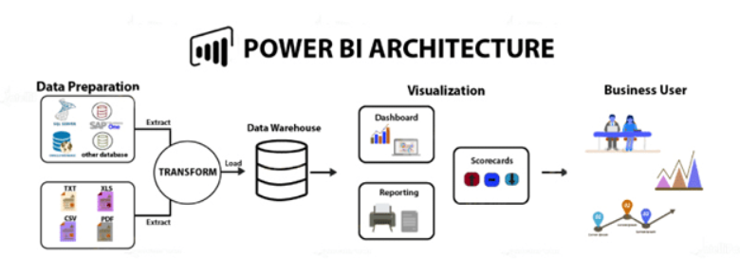

**4. KPI**

Dashboards will be implemented to display and indicate certain KPIs and relevant indicators for Bird Strike Data in US.

1.1 Visuals Depicting the Number of Bird Strikes:

1.1.1Yearly Analysis.

1.1.2 Bird Strikes in US.

1.1.3 Top 10 US Airlines in terms of having encountered bird strikes.

1.1.4 Airports with most incidents of bird strikes – Top 50.

1.2 Yearly Cost Incurred due to Bird Strikes.

1.3 When do most bird strikes occur?

1.3.1 Altitude of airplanes at the time of strike.

1.3.2 Phase of flight at the time of strike.

1.3.3 Average Altitude of the airplanes in different phases at the time of strike.

1.4 Effect of Bird Strikes

1.4.1 Impact on Flight.

1.4.2 Effect of Strike at Different Altitude.

1.4.3 Were Pilots Informed?

1.4.4 Prior Warning and Effect of Strike Relation.

**5. Deployment**

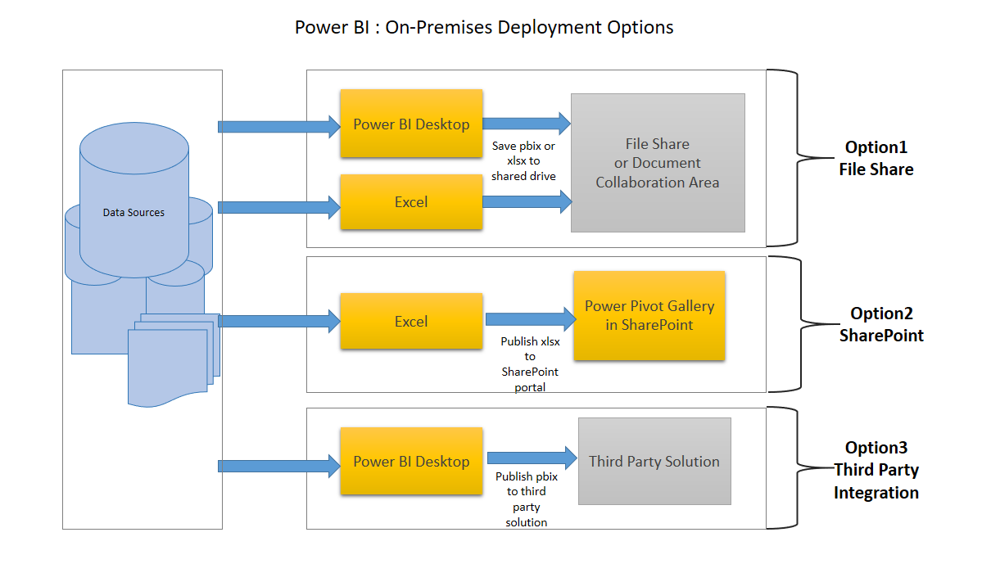

**5.1 Pros and Cons of Power BI Public**

**i. Pros of Power BI Public**

1. **Affordability**: A major advantage of using Power BI for data analysis and visualization is that it is affordable and relatively inexpensive. The Power BI Desktop version is free of cost.

2. **Custom Visualizations**: Power BI offers a wide range of custom visualizations i.e. visualizations made by developers for a specific use. Custom visuals are available on Microsoft marketplace. In addition to the general set of visualizations available you can use Power BI custom visualizations in your reports and dashboards. The range of custom visualizations includes KPIs, maps, charts, graphs, R script visuals, etc.

3. **Excel Integration**: In Power BI, you also have the option to upload and view your data in Excel. You can select/filter/slice data in a Power BI report or dashboard and put it on Excel. You can then open Excel and view the same data in tabular form in an Excel spreadsheet. In other words, Power BI’s capability of Excel integration helps users to view and work with the raw data behind a Power BI visualization.

**ii. Cons of Power BI Public**

1. **Table Relationships**: Power BI is good with handling simple relationships between tables in a data model. But, if there are complex relationships between tables, that is, if they have more than one links between tables, Power BI might not handle them well. You need to create a data model carefully by having more unique fields so that Power BI does not confuse the relationships when it comes to complex relationships.

2. **Configuration of Visuals**: In most cases, you might not feel the need to configure and optimize visualizations in Power BI. But even if you do, Power BI does not provide many options to configure your visualizations as per your requirements. Thus, users have limited options for what they can change in visuals.

3. **Crowded User Interface**: The user interface of Power BI is often found crowded and bulky by the users. It is in the sense that there are many icons of options that block the view of dashboard or report. Most users wish that the user interface or the report canvas was clearer with fewer icons and options. Also, creating scrolling dashboards is a native feature.